**GRT INSITITUTE OF ENGINEERING ANDTECHNOLOGY–TIRUTTANI–**

**631209**

Affiliated to Anna University, Chennai, An ISO9001:2015certifiedinstitution.



**DEPARTMENT OF ELECTRONICS AND COMMUNICATION ENGINEERING**

**NAAN MUDHALVAN-IBM(AI) PROJECT**

IBM AL 101 ARTIFICIAL INTELLIGENCE-GROUP 1(TEAM 5)

**PROJECT TITLE:**

CREATE A CHATBOT USING PYTHON

**SUBMITTED BY:**

NAME: KALAI PRIYA S G

NM ID: au110321121016

Year/sem: III/V

COLLEGE CODE: 1103

MAIL ID: sgkalaipriya21@gmail.com

**Phase 4: DEVELOPMENT PART 2:**

**1.What is a Chatbot?**

* A chatbot is an AI-based software designed to interact with humans in their natural languages. These chatbots are usually converse via auditory or textual methods, and they can effortlessly mimic human languages to communicate with human beings in a human-like manner. A chatbot is arguably one of the best applications of natural language processing.

**2.How to Make a Chatbot in Python?**

* In the past few years, chatbots in Python have become wildly popular in the tech and business sectors. These intelligent bots are so adept at imitating natural human languages and conversing with humans, that companies across various industrial sectors are adopting them. From e-commerce firms to healthcare institutions, everyone seems to be leveraging this nifty tool to drive business benefits.
* To build a chatbot in Python, import all the necessary packages and initialize the variables you want to use in chatbot project. Also, when working with text data, we need to perform data preprocessing on your dataset before designing an ML model.
* This is where tokenizing helps with text data – it helps fragment the large text dataset into smaller, readable chunks (like words). Once that is done, you can also go for lemmatization that transforms a word into its lemma form. Then it creates a pickle file to store the python objects that are used for predicting the responses of the bot.
* Another vital part of the chatbot development process is creating the training and testing datasets.

**3.Table of Contents:**

* Import Libraries
* Data Preprocessing

1. Data Visualization
2. Text Cleaning
3. Tokenization

* Build Models

1. Build Encoder
2. Build Training Model
3. Train Model

* Visualize Metrics
* Save Model
* Create Inference Model
* Time to Chat

1. **Import Libraries:**

This code snippet imports TensorFlow, NumPy, Pandas, Matplotlib, Seaborn, and various components from TensorFlow's Keras module. It also imports the re and string modules for regular expressions and string manipulation. The code prepares your environment for working with deep learning and natural language processing.

**Input 1-2:**

import tensorflow as tf

import numpy as np

import pandas as pd

import matplotlib.pyplot as plt

import seaborn as sns

from tensorflow.keras.layers import TextVectorization

import re,string

from tensorflow.keras.layers import LSTM,Dense,Embedding,Dropout,LayerNormalization

1. **Data Preprocessing:**

* **Data Visualization:**

This code calculates the number of tokens (words) in the 'question' and 'answer' columns of a Pandas DataFrame and then visualizes the token distribution using Matplotlib and Seaborn. The resulting plots are displayed in a single figure with two subplots for token distributions and a joint distribution between 'question' and 'answer' tokens.

Input 3:

df['question tokens'] = df['question'].apply(lambda x: len(x.split()))

df['answer tokens'] = df['answer'].apply(lambda x: len(x.split()))

import matplotlib.pyplot as plt

import seaborn as sns

plt.style.use('fivethirtyeight')

fig, ax = plt.subplots(nrows=1, ncols=2, figsize=(20, 5))

sns.set_palette('Set2')

sns.histplot(x=df['question tokens'], data=df, kde=True, ax=ax[0])

sns.histplot(x=df['answer tokens'], data=df, kde=True, ax=ax[1])

sns.jointplot(x='question tokens', y='answer tokens', data=df, kind='kde', fill=True, cmap='YlGnBu')

plt.show()

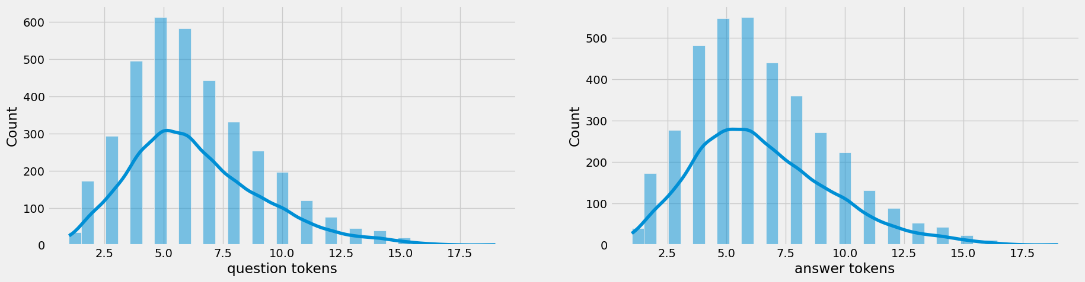

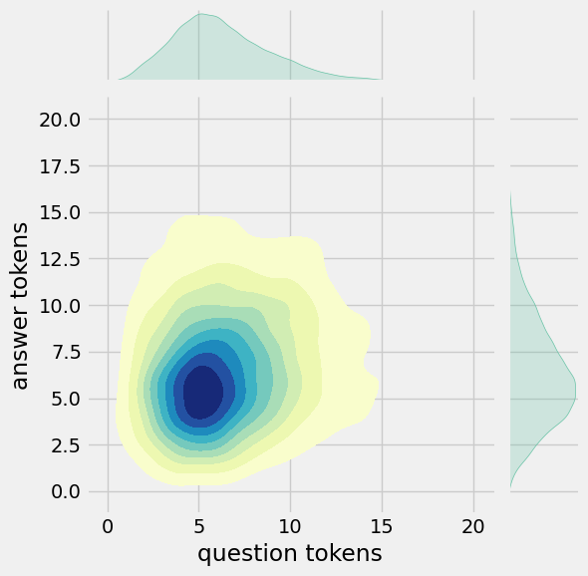

* **Text Cleaning:**

This code defines a clean_text function to clean the text and then applies this function to the 'question' and 'answer' columns in the DataFrame. It also modifies the DataFrame by creating 'encoder_inputs', 'decoder_targets', and 'decoder_inputs' columns.

**Input 4:**

def clean_text(text):

text = re.sub('-', ' ', text.lower())

text = re.sub('[.]', ' . ', text)

text = re.sub('[1]', ' 1 ', text)

text = re.sub('[2]', ' 2 ', text)

text = re.sub('[3]', ' 3 ', text)

text = re.sub('[4]', ' 4 ', text)

text = re.sub('[5]', ' 5 ', text)

text = re.sub('[6]', ' 6 ', text)

text = re.sub('[7]', ' 7 ', text)

text = re.sub('[8]', ' 8 ', text)

text = re.sub('[9]', ' 9 ', text)

text = re.sub('[0]', ' 0 ', text)

text = re.sub(',', ' , ', text)

text = re.sub('?', ' ? ', text)

text = re.sub('!', ' ! ', text)

text = re.sub('$', ' $ ', text)

text = re.sub('&', ' & ', text)

text = re.sub('/', ' / ', text)

text = re.sub(':', ' : ', text)

text = re.sub(';', ' ; ', text)

text = re.sub('*', ' * ', text)

text = re.sub("'", " ' ", text)

text = re.sub('"', ' " ', text)

text = re.sub('\t', ' ', text)

return text

df.drop(columns=['answer tokens', 'question tokens'], axis=1, inplace=True)

df['encoder_inputs'] = df['question'].apply(clean_text)

df['decoder_targets'] = df['answer'].apply(clean_text) + ' <end>'

df['decoder_inputs'] = '<start> ' + df['answer'].apply(clean_text) + ' <end>'

df.head(10)

| 0 | hi, how are you doing? | i'm fine. how about yourself? | hi , how are you doing ? | i ' m fine . how about yourself ? <end> | <start> i ' m fine . how about yourself ? <end> |
| --- | --- | --- | --- | --- | --- |
| 1 | i'm fine. how about yourself? | i'm pretty good. thanks for asking. | i ' m fine . how about yourself ? | i ' m pretty good . thanks for asking . <end> | <start> i ' m pretty good . thanks for asking... |
| 2 | i'm pretty good. thanks for asking. | no problem. so how have you been? | i ' m pretty good . thanks for asking . | no problem . so how have you been ? <end> | <start> no problem . so how have you been ? ... |
| 3 | no problem. so how have you been? | i've been great. what about you? | no problem . so how have you been ? | i ' ve been great . what about you ? <end> | <start> i ' ve been great . what about you ? ... |
| 4 | i've been great. what about you? | i've been good. i'm in school right now. | i ' ve been great . what about you ? | i ' ve been good . i ' m in school right now ... | <start> i ' ve been good . i ' m in school ri... |
| 5 | i've been good. i'm in school right now. | what school do you go to? | i ' ve been good . i ' m in school right now . | what school do you go to ? <end> | <start> what school do you go to ? <end> |
| 6 | what school do you go to? | i go to pcc. | what school do you go to ? | i go to pcc . <end> | <start> i go to pcc . <end> |
| 7 | i go to pcc. | do you like it there? | i go to pcc . | do you like it there ? <end> | <start> do you like it there ? <end> |
| 8 | do you like it there? | it's okay. it's a really big campus. | do you like it there ? | it ' s okay . it ' s a really big campus . <... | <start> it ' s okay . it ' s a really big cam... |
| 9 | it's okay. it's a really big campus. | good luck with school. | it ' s okay . it ' s a really big campus . | good luck with school . <end> | <start> good luck with school . <end> |

Input 5:

df['encoder input tokens'] = df['encoder_inputs'].apply(lambda x: len(x.split()))

df['decoder input tokens'] = df['decoder_inputs'].apply(lambda x: len(x.split()))

df['decoder target tokens'] = df['decoder_targets'].apply(lambda x: len(x.split()))

import matplotlib.pyplot as plt

import seaborn as sns

plt.style.use('fivethirtyeight')

fig, ax = plt.subplots(nrows=1, ncols=3, figsize=(20, 5))

sns.set_palette('Set2')

sns.histplot(x=df['encoder input tokens'], data=df, kde=True, ax=ax[0])

sns.histplot(x=df['decoder input tokens'], data=df, kde=True, ax=ax[1])

sns.histplot(x=df['decoder target tokens'], data=df, kde=True, ax=ax[2])

sns.jointplot(x='encoder input tokens', y='decoder target tokens', data=df, kind='kde', fill=True, cmap='YlGnBu')

plt.show()

This code calculates the token counts for 'encoder_inputs', 'decoder_inputs', and 'decoder_targets' columns in the DataFrame and then visualizes the token distribution using Matplotlib and Seaborn. The resulting plots are displayed in a single figure with three subplots for the token counts and a joint distribution between 'encoder input tokens' and 'decoder target tokens'.

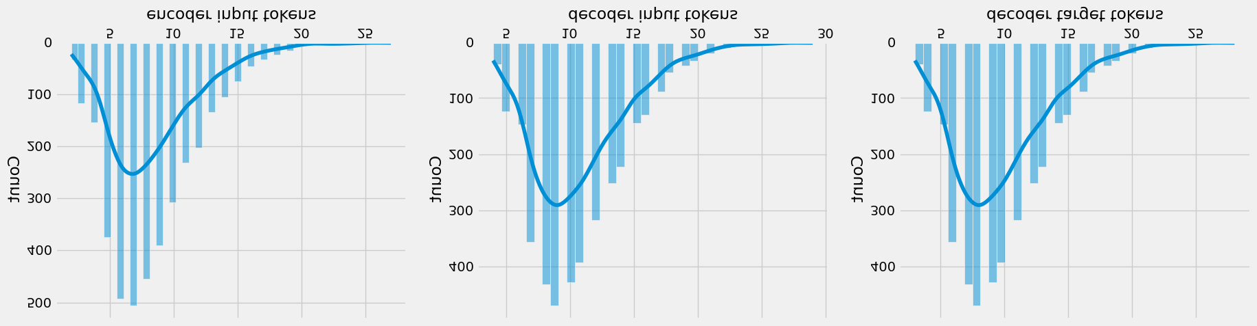

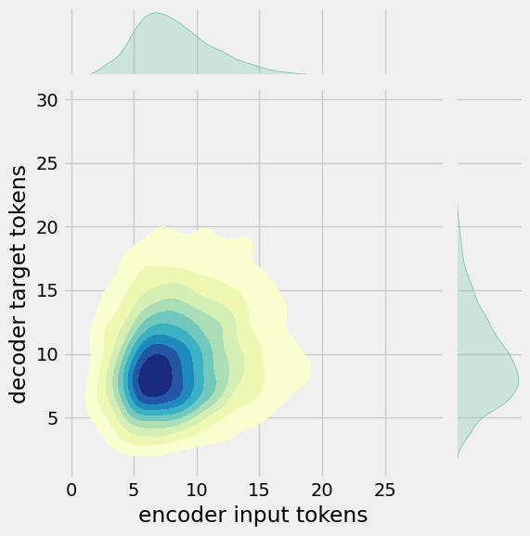

Input 6:

print(f"After preprocessing: {' '.join(df[df['encoder input tokens'].max()==df['encoder input tokens']]['encoder_inputs'].values.tolist())}")

print(f"Max encoder input length: {df['encoder input tokens'].max()}")

print(f"Max decoder input length: {df['decoder input tokens'].max()}")

print(f"Max decoder target length: {df['decoder target tokens'].max()}")

df.drop(columns=['question','answer','encoder input tokens','decoder input tokens','decoder target tokens'],axis=1,inplace=True)

params={

"vocab_size":2500,

"max_sequence_length":30,

"learning_rate":0.008,

"batch_size":149,

"lstm_cells":256,

"embedding_dim":256,

"buffer_size":10000

}

learning_rate=params['learning_rate']

batch_size=params['batch_size']

embedding_dim=params['embedding_dim']

lstm_cells=params['lstm_cells']

vocab_size=params['vocab_size']

buffer_size=params['buffer_size']

max_sequence_length=params['max_sequence_length']

df.head(10)

**Output:**

| encoder_inputs | decoder_targets | decoder_inputs |
| --- | --- | --- |
| 0 | hi , how are you doing ? | i ' m fine . how about yourself ? <end> | <start> i ' m fine . how about yourself ? <end> |
| 1 | i ' m fine . how about yourself ? | i ' m pretty good . thanks for asking . <end> | <start> i ' m pretty good . thanks for asking... |
| 2 | i ' m pretty good . thanks for asking . | no problem . so how have you been ? <end> | <start> no problem . so how have you been ? ... |
| 3 | no problem . so how have you been ? | i ' ve been great . what about you ? <end> | <start> i ' ve been great . what about you ? ... |
| 4 | i ' ve been great . what about you ? | i ' ve been good . i ' m in school right now ... | <start> i ' ve been good . i ' m in school ri... |
| 5 | i ' ve been good . i ' m in school right now . | what school do you go to ? <end> | <start> what school do you go to ? <end> |
| 6 | what school do you go to ? | i go to pcc . <end> | <start> i go to pcc . <end> |
| 7 | i go to pcc . | do you like it there ? <end> | <start> do you like it there ? <end> |
| 8 | do you like it there ? | it ' s okay . it ' s a really big campus . <... | <start> it ' s okay . it ' s a really big cam... |
| 9 | it ' s okay . it ' s a really big campus . | good luck with school . <end> | <start> good luck with school . <end> |

* **Tokenization:**

This code snippet involves data preprocessing, including text vectorization using TensorFlow's TextVectorization layer, conversion between sequences and IDs, and the creation of training and validation datasets using TensorFlow's Dataset API. It also prints various details about the data, such as batch sizes and shapes.

Input 7:

vectorize_layer=TextVectorization(

max_tokens=vocab_size,

standardize=None,

output_mode='int',

output_sequence_length=max_sequence_length

)

vectorize_layer.adapt(df['encoder_inputs']+' '+df['decoder_targets']+' <start> <end>')

vocab_size=len(vectorize_layer.get_vocabulary())

print(f'Vocab size: {len(vectorize_layer.get_vocabulary())}')

print(f'{vectorize_layer.get_vocabulary()[:12]}')

Vocab size: 2443

['', '[UNK]', '<end>', '.', '<start>', "'", 'i', '?', 'you', ',', 'the', 'to']

Input 8:

def sequences2ids(sequence):

return vectorize_layer(sequence)

def ids2sequences(ids):

decode=''

if type(ids)==int:

ids=[ids]

for id in ids:

decode+=vectorize_layer.get_vocabulary()[id]+' '

return decode

x=sequences2ids(df['encoder_inputs'])

yd=sequences2ids(df['decoder_inputs'])

y=sequences2ids(df['decoder_targets'])

print(f'Question sentence: hi , how are you ?')

print(f'Question to tokens: {sequences2ids("hi , how are you ?")[:10]}')

print(f'Encoder input shape: {x.shape}')

print(f'Decoder input shape: {yd.shape}')

print(f'Decoder target shape: {y.shape}')

Question sentence: hi , how are you ?

Question to tokens: [1971 9 45 24 8 7 0 0 0 0]

Encoder input shape: (3725, 30)

Decoder input shape: (3725, 30)

Decoder target shape: (3725, 30)

Input 9:

print(f'Encoder input: {x[0][:12]} ...')

print(f'Decoder input: {yd[0][:12]} ...') # shifted by one time step of the target as input to decoder is the output of the previous timestep

print(f'Decoder target: {y[0][:12]} ...')

Encoder input: [1971 9 45 24 8 194 7 0 0 0 0 0] ...

Decoder input: [ 4 6 5 38 646 3 45 41 563 7 2 0] ...

Decoder target: [ 6 5 38 646 3 45 41 563 7 2 0 0] …

Input 10:

data=tf.data.Dataset.from_tensor_slices((x,yd,y))

data=data.shuffle(buffer_size)

train_data=data.take(int(.9*len(data)))

train_data=train_data.cache()

train_data=train_data.shuffle(buffer_size)

train_data=train_data.batch(batch_size)

train_data=train_data.prefetch(tf.data.AUTOTUNE)

train_data_iterator=train_data.as_numpy_iterator()

val_data=data.skip(int(.9*len(data))).take(int(.1*len(data)))

val_data=val_data.batch(batch_size)

val_data=val_data.prefetch(tf.data.AUTOTUNE)

_=train_data_iterator.next()

print(f'Number of train batches: {len(train_data)}')

print(f'Number of training data: {len(train_data)*batch_size}')

print(f'Number of validation batches: {len(val_data)}')

print(f'Number of validation data: {len(val_data)*batch_size}')

print(f'Encoder Input shape (with batches): {_[0].shape}')

print(f'Decoder Input shape (with batches): {_[1].shape}')

print(f'Target Output shape (with batches): {_[2].shape}')

Number of train batches: 23

Number of training data: 3427

Number of validation batches: 3

Number of validation data: 447

Encoder Input shape (with batches): (149, 30)

Decoder Input shape (with batches): (149, 30)

Target Output shape (with batches): (149, 30)

1. Build Models:

* Build Encoder:

This code defines classes for the encoder and decoder in a sequence-to-sequence model. The encoder processes input sequences, and the decoder generates output sequences. The provided code includes details about the layers, embeddings, and initializations used in both the encoder and decoder components. It also demonstrates the usage of these components by making a forward pass with example data.

Input 11:

class Encoder(tf.keras.models.Model):

def __init__(self,units,embedding_dim,vocab_size,*args,**kwargs) -> None:

super().__init__(*args,**kwargs)

self.units=units

self.vocab_size=vocab_size

self.embedding_dim=embedding_dim

self.embedding=Embedding(

vocab_size,

embedding_dim,

name='encoder_embedding',

mask_zero=True,

embeddings_initializer=tf.keras.initializers.GlorotNormal()

)

self.normalize=LayerNormalization()

self.lstm=LSTM(

units,

dropout=.4,

return_state=True,

return_sequences=True,

name='encoder_lstm',

kernel_initializer=tf.keras.initializers.GlorotNormal()

)

def call(self,encoder_inputs):

self.inputs=encoder_inputs

x=self.embedding(encoder_inputs)

x=self.normalize(x)

x=Dropout(.4)(x)

encoder_outputs,encoder_state_h,encoder_state_c=self.lstm(x)

self.outputs=[encoder_state_h,encoder_state_c]

return encoder_state_h,encoder_state_c

encoder=Encoder(lstm_cells,embedding_dim,vocab_size,name='encoder')

encoder.call(_[0])

OUTPUT:

(<tf.Tensor: shape=(149, 256), dtype=float32, numpy=

array([[ 0.16966951, -0.10419625, -0.12700348, ..., -0.12251794,

0.10568858, 0.14841646],

[ 0.08443093, 0.08849293, -0.09065959, ..., -0.00959182,

0.10152507, -0.12077457],

[ 0.03628462, -0.02653611, -0.11506603, ..., -0.14669597,

0.10292757, 0.13625325],

...,

[-0.14210635, -0.12942064, -0.03288083, ..., 0.0568463 ,

-0.02598592, -0.22455114],

[ 0.20819993, 0.01196991, -0.09635217, ..., -0.18782297,

0.10233591, 0.20114912],

[ 0.1164271 , -0.07769038, -0.06414707, ..., -0.06539135,

-0.05518465, 0.25142196]], dtype=float32)>,

<tf.Tensor: shape=(149, 256), dtype=float32, numpy=

array([[ 0.34589 , -0.30134732, -0.43572 , ..., -0.3102559 ,

0.34630865, 0.2613009 ],

[ 0.14154069, 0.17045322, -0.17749965, ..., -0.02712595,

0.17292541, -0.2922624 ],

[ 0.07106856, -0.0739173 , -0.3641197 , ..., -0.3794833 ,

0.36470377, 0.23766585],

...,

[-0.2582597 , -0.25323495, -0.06649272, ..., 0.16527973,

-0.04292646, -0.58768904],

[ 0.43155715, 0.03135502, -0.33463806, ..., -0.47625306,

0.33486888, 0.35035062],

[ 0.23173636, -0.20141824, -0.22034441, ..., -0.16035017,

-0.17478186, 0.48899865]], dtype=float32)>)

Build Encoder## Build Decoder

Input 12:

class Decoder(tf.keras.models.Model):

def __init__(self,units,embedding_dim,vocab_size,*args,**kwargs) -> None:

super().__init__(*args,**kwargs)

self.units=units

self.embedding_dim=embedding_dim

self.vocab_size=vocab_size

self.embedding=Embedding(

vocab_size,

embedding_dim,

name='decoder_embedding',

mask_zero=True,

embeddings_initializer=tf.keras.initializers.HeNormal()

)

self.normalize=LayerNormalization()

self.lstm=LSTM(

units,

dropout=.4,

return_state=True,

return_sequences=True,

name='decoder_lstm',

kernel_initializer=tf.keras.initializers.HeNormal()

)

self.fc=Dense(

vocab_size,

activation='softmax',

name='decoder_dense',

kernel_initializer=tf.keras.initializers.HeNormal()

)

def call(self,decoder_inputs,encoder_states):

x=self.embedding(decoder_inputs)

x=self.normalize(x)

x=Dropout(.4)(x)

x,decoder_state_h,decoder_state_c=self.lstm(x,initial_state=encoder_states)

x=self.normalize(x)

x=Dropout(.4)(x)

return self.fc(x)

decoder=Decoder(lstm_cells,embedding_dim,vocab_size,name='decoder')

decoder(_[1][:1],encoder(_[0][:1]))

OUTPUT:

<tf.Tensor: shape=(1, 30, 2443), dtype=float32, numpy=

array([[[3.4059247e-04, 5.7348556e-05, 2.1294907e-05, ...,

7.2067953e-05, 1.5453645e-03, 2.3599296e-04],

[1.4662130e-03, 8.0250365e-06, 5.4062020e-05, ...,

1.9187471e-05, 9.7244098e-05, 7.6433855e-05],

[9.6929165e-05, 2.7441782e-05, 1.3761305e-03, ...,

3.6009602e-05, 1.5537882e-04, 1.8397317e-04],

...,

[1.9002777e-03, 6.9266016e-04, 1.4346189e-04, ...,

1.9552530e-04, 1.7106640e-05, 1.0252406e-04],

[1.9002777e-03, 6.9266016e-04, 1.4346189e-04, ...,

1.9552530e-04, 1.7106640e-05, 1.0252406e-04],

[1.9002777e-03, 6.9266016e-04, 1.4346189e-04, ...,

1.9552530e-04, 1.7106640e-05, 1.0252406e-04]]], dtype=float32)>

* **Build Training Model:**

This code defines a ChatBotTrainer class for training and testing a chatbot model. It includes custom loss and accuracy functions, training and testing steps, and the compilation of the model. The code then performs a forward pass with the model using example data.

**INPUT-13**

class ChatBotTrainer(tf.keras.models.Model):

def __init__(self,encoder,decoder,*args,**kwargs):

super().__init__(*args,**kwargs)

self.encoder=encoder

self.decoder=decoder

def loss_fn(self,y_true,y_pred):

loss=self.loss(y_true,y_pred)

mask=tf.math.logical_not(tf.math.equal(y_true,0))

mask=tf.cast(mask,dtype=loss.dtype)

loss*=mask

return tf.reduce_mean(loss)

def accuracy_fn(self,y_true,y_pred):

pred_values = tf.cast(tf.argmax(y_pred, axis=-1), dtype='int64')

correct = tf.cast(tf.equal(y_true, pred_values), dtype='float64')

mask = tf.cast(tf.greater(y_true, 0), dtype='float64')

n_correct = tf.keras.backend.sum(mask * correct)

n_total = tf.keras.backend.sum(mask)

return n_correct / n_total

def call(self,inputs):

encoder_inputs,decoder_inputs=inputs

encoder_states=self.encoder(encoder_inputs)

return self.decoder(decoder_inputs,encoder_states)

def train_step(self,batch):

encoder_inputs,decoder_inputs,y=batch

with tf.GradientTape() as tape:

encoder_states=self.encoder(encoder_inputs,training=True)

y_pred=self.decoder(decoder_inputs,encoder_states,training=True)

loss=self.loss_fn(y,y_pred)

acc=self.accuracy_fn(y,y_pred)

variables=self.encoder.trainable_variables+self.decoder.trainable_variables

grads=tape.gradient(loss,variables)

self.optimizer.apply_gradients(zip(grads,variables))

metrics={'loss':loss,'accuracy':acc}

return metrics

def test_step(self,batch):

encoder_inputs,decoder_inputs,y=batch

encoder_states=self.encoder(encoder_inputs,training=True)

y_pred=self.decoder(decoder_inputs,encoder_states,training=True)

loss=self.loss_fn(y,y_pred)

acc=self.accuracy_fn(y,y_pred)

metrics={'loss':loss,'accuracy':acc}

return metrics

INPUT-14

model=ChatBotTrainer(encoder,decoder,name='chatbot_trainer')

model.compile(

loss=tf.keras.losses.SparseCategoricalCrossentropy(),

optimizer=tf.keras.optimizers.Adam(learning_rate=learning_rate),

weighted_metrics=['loss','accuracy']

)

model(_[:2])

* **Train Model:**

In this code, the model.fit function is used to train the model for 100 epochs with training data (train_data) and validation data (val_data). Two callbacks are specified: the TensorBoard callback for monitoring the training process and the ModelCheckpoint callback to save the best model during training. The training history is stored in the history variable.

Input- 15

history=model.fit(

train_data,

epochs=100,

validation_data=val_data,

callbacks=[

tf.keras.callbacks.TensorBoard(log_dir='logs'),

tf.keras.callbacks.ModelCheckpoint('ckpt',verbose=1,save_best_only=True)

]

)

**IV.Visualize Metrics:**

This code creates a figure with two subplots to visualize training and validation loss and accuracy metrics over training epochs. It uses Matplotlib for plotting and shows the resulting figure.

Input-16

fig,ax=plt.subplots(nrows=1,ncols=2,figsize=(20,5))

ax[0].plot(history.history['loss'],label='loss',c='red')

ax[0].plot(history.history['val_loss'],label='val_loss',c = 'blue')

ax[0].set_xlabel('Epochs')

ax[1].set_xlabel('Epochs')

ax[0].set_ylabel('Loss')

ax[1].set_ylabel('Accuracy')

ax[0].set_title('Loss Metrics')

ax[1].set_title('Accuracy Metrics')

ax[1].plot(history.history['accuracy'],label='accuracy')

ax[1].plot(history.history['val_accuracy'],label='val_accuracy')

ax[0].legend()

ax[1].legend()

plt.show()

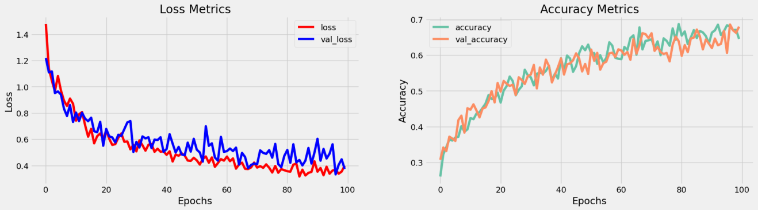

**V.Save Model**

model.load_weights('ckpt')

model.save('models',save_format='tf')

for idx,i in enumerate(model.layers):

print('Encoder layers:' if idx==0 else 'Decoder layers: ')

for j in i.layers:

print(j)

print('---------------------')

**VI.Create Inference Model**

class ChatBot(tf.keras.models.Model):

def __init__(self,base_encoder,base_decoder,*args,**kwargs):

super().__init__(*args,**kwargs)

self.encoder,self.decoder=self.build_inference_model(base_encoder,base_decoder)

def build_inference_model(self,base_encoder,base_decoder):

encoder_inputs=tf.keras.Input(shape=(None,))

x=base_encoder.layers[0](encoder_inputs)

x=base_encoder.layers[1](x)

x,encoder_state_h,encoder_state_c=base_encoder.layers[2](x)

encoder=tf.keras.models.Model(inputs=encoder_inputs,outputs=[encoder_state_h,encoder_state_c],name='chatbot_encoder')

decoder_input_state_h=tf.keras.Input(shape=(lstm_cells,))

decoder_input_state_c=tf.keras.Input(shape=(lstm_cells,))

decoder_inputs=tf.keras.Input(shape=(None,))

x=base_decoder.layers[0](decoder_inputs)

x=base_encoder.layers[1](x)

x,decoder_state_h,decoder_state_c=base_decoder.layers[2](x,initial_state=[decoder_input_state_h,decoder_input_state_c])

decoder_outputs=base_decoder.layers[-1](x)

decoder=tf.keras.models.Model(

inputs=[decoder_inputs,[decoder_input_state_h,decoder_input_state_c]],

outputs=[decoder_outputs,[decoder_state_h,decoder_state_c]],name='chatbot_decoder'

)

return encoder,decoder

def summary(self):

self.encoder.summary()

self.decoder.summary()

def softmax(self,z):

return np.exp(z)/sum(np.exp(z))

def sample(self,conditional_probability,temperature=0.5):

conditional_probability = np.asarray(conditional_probability).astype("float64")

conditional_probability = np.log(conditional_probability) / temperature

reweighted_conditional_probability = self.softmax(conditional_probability)

probas = np.random.multinomial(1, reweighted_conditional_probability, 1)

return np.argmax(probas)

def preprocess(self,text):

text=clean_text(text)

seq=np.zeros((1,max_sequence_length),dtype=np.int32)

for i,word in enumerate(text.split()):

seq[:,i]=sequences2ids(word).numpy()[0]

return seq

def postprocess(self,text):

text=re.sub(' - ','-',text.lower())

text=re.sub(' [.] ','. ',text)

text=re.sub(' [1] ','1',text)

text=re.sub(' [2] ','2',text)

text=re.sub(' [3] ','3',text)

text=re.sub(' [4] ','4',text)

text=re.sub(' [5] ','5',text)

text=re.sub(' [6] ','6',text)

text=re.sub(' [7] ','7',text)

text=re.sub(' [8] ','8',text)

text=re.sub(' [9] ','9',text)

text=re.sub(' [0] ','0',text)

text=re.sub(' [,] ',', ',text)

text=re.sub(' [?] ','? ',text)

text=re.sub(' [!] ','! ',text)

text=re.sub(' [$] ','$ ',text)

text=re.sub(' [&] ','& ',text)

text=re.sub(' [/] ','/ ',text)

text=re.sub(' [:] ',': ',text)

text=re.sub(' [;] ','; ',text)

text=re.sub(' [*] ','* ',text)

text=re.sub(' [\'] ','\'',text)

text=re.sub(' [\"] ','\"',text)

return text

def call(self,text,config=None):

input_seq=self.preprocess(text)

states=self.encoder(input_seq,training=False)

target_seq=np.zeros((1,1))

target_seq[:,:]=sequences2ids(['<start>']).numpy()[0][0]

stop_condition=False

decoded=[]

while not stop_condition:

decoder_outputs,new_states=self.decoder([target_seq,states],training=False)

# index=tf.argmax(decoder_outputs[:,-1,:],axis=-1).numpy().item()

index=self.sample(decoder_outputs[0,0,:]).item()

word=ids2sequences([index])

if word=='<end> ' or len(decoded)>=max_sequence_length:

stop_condition=True

else:

decoded.append(index)

target_seq=np.zeros((1,1))

target_seq[:,:]=index

states=new_states

return self.postprocess(ids2sequences(decoded))

chatbot=ChatBot(model.encoder,model.decoder,name='chatbot')

chatbot.summary()

Model: "chatbot_encoder"

_________________________________________________________________

Layer (type) Output Shape Param #

=================================================================

input_1 (InputLayer) [(None, None)] 0

encoder_embedding (Embeddin (None, None, 256) 625408

g)

layer_normalization (LayerN (None, None, 256) 512

ormalization)

encoder_lstm (LSTM) [(None, None, 256), 525312

(None, 256),

(None, 256)]

=================================================================

Total params: 1,151,232

Trainable params: 1,151,232

Non-trainable params: 0

_________________________________________________________________

Model: "chatbot_decoder"

__________________________________________________________________________________________________

Layer (type) Output Shape Param # Connected to

==================================================================================================

input_4 (InputLayer) [(None, None)] 0 []

decoder_embedding (Embedding) (None, None, 256) 625408 ['input_4[0][0]']

layer_normalization (LayerNorm (None, None, 256) 512 ['decoder_embedding[0][0]']

alization)

input_2 (InputLayer) [(None, 256)] 0 []

input_3 (InputLayer) [(None, 256)] 0 []

decoder_lstm (LSTM) [(None, None, 256), 525312 ['layer_normalization[1][0]',

(None, 256), 'input_2[0][0]',

(None, 256)] 'input_3[0][0]']

decoder_dense (Dense) (None, None, 2443) 627851 ['decoder_lstm[0][0]']

==================================================================================================

Total params: 1,779,083

Trainable params: 1,779,083

Non-trainable params: 0

__________________________________________________________________________________________________

tf.keras.utils.plot_model(chatbot.encoder,to_file='encoder.png',show_shapes=True,show_layer_activations=True)

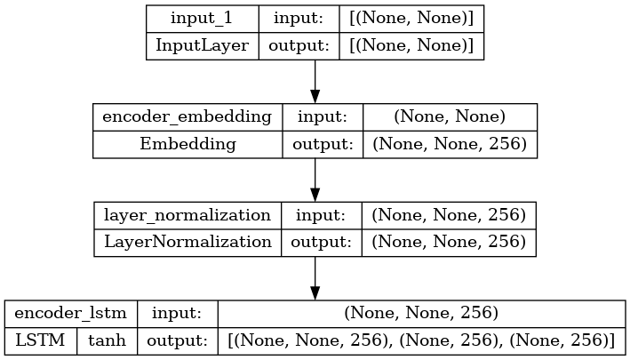

tf.keras.utils.plot_model(chatbot.decoder,to_file='decoder.png',show_shapes=True,show_layer_activations=True)

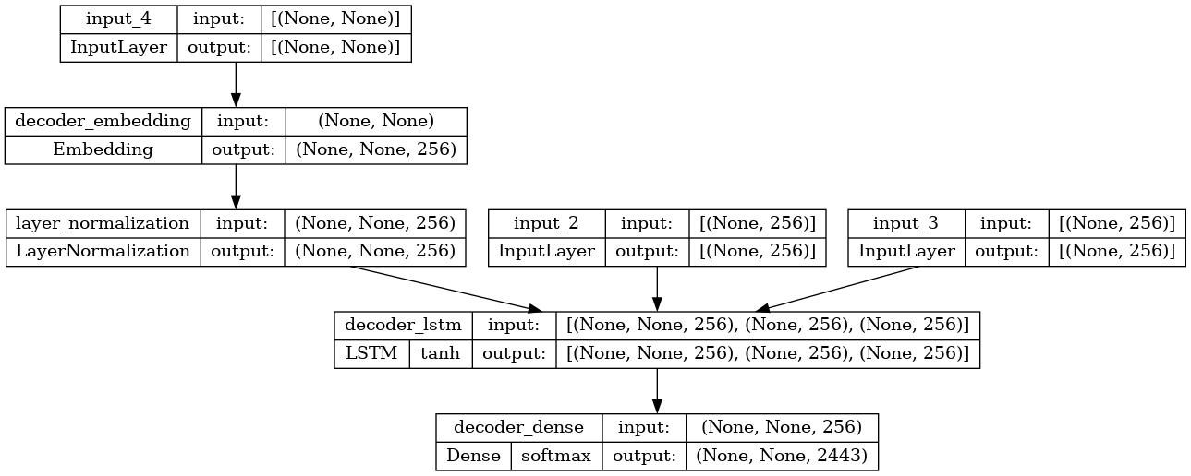

VII.Time to Chat

def print_conversation(texts):

for text in texts:

print(f'You: {text}')

print(f'Bot: {chatbot(text)}')

print('========================')

print_conversation([

'hi',

'do yo know me?',

'what is your name?',

'you are bot?',

'hi, how are you doing?',

"i'm pretty good. thanks for asking.",

"Don't ever be in a hurry",

'''I'm gonna put some dirt in your eye ''',

'''You're trash ''',

'''I've read all your research on nano-technology ''',

'''You want forgiveness? Get religion''',

'''While you're using the bathroom, i'll order some food.''',

'''Wow! that's terrible.''',

'''We'll be here forever.''',

'''I need something that's reliable.''',

'''A speeding car ran a red light, killing the girl.''',

'''Tomorrow we'll have rice and fish for lunch.''',

'''I like this restaurant because they give you free bread.'''])

OUTPUT:

You: hi

Bot: i have to go to the bathroom.

========================

You: do yo know me?

Bot: yes, it's too close to the other.

========================

You: what is your name?

Bot: i have to walk the house.

========================

You: you are bot?

Bot: no, i have. all my life.

========================

You: hi, how are you doing?

Bot: i'm going to be a teacher.

========================

You: i'm pretty good. thanks for asking.

Bot: no problem. i'll have to give you the english assignments from my mind.

========================

You: Don't ever be in a hurry

Bot: it's not a great.

========================

You: I'm gonna put some dirt in your eye

Bot: that's a good idea.

========================

You: You're trash

Bot: the tv news is reporting a bank robbery.

========================

You: I've read all your research on nano-technology

Bot: it's the weather. i've gone around the world.

========================

You: You want forgiveness? Get religion

Bot: no, i'll be my.

========================

You: While you're using the bathroom, i'll order some food.

Bot: don't order for me. i've been a cheater.

========================

You: Wow! that's terrible.

Bot: never park your car under the house.

========================

You: We'll be here forever.

Bot: we'll be there in half an hour.

========================

You: I need something that's reliable.

Bot: you need a car with low mileage.

========================

You: A speeding car ran a red light, killing the girl.

Bot: what happened?

========================

You: Tomorrow we'll have rice and fish for lunch.

Bot: i'll make a sandwich.

========================

You: I like this restaurant because they give you free bread.

Bot: well, i think that's a good idea.

**FULL SOURCE CODE FOR THIS PROJECT:**

import numpy as np

import pandas as pd

import matplotlib.pyplot as plt

import seaborn as sns

import pandas as pd

import re,string

data = {

'question': [

"hi, how are you doing?",

"i'm fine. how about yourself?",

"i'm pretty good. thanks for asking.",

"no problem. so how have you been?",

"i've been great. what about you?"

],

'answer': [

"i'm fine. how about yourself?",

"i'm pretty good. thanks for asking.",

"no problem. so how have you been?",

"i've been great. what about you?",

"i've been good. i'm in school right now."

]

}

df = pd.DataFrame(data)

print(df)

df['question tokens']=df['question'].apply(lambda x:len(x.split()))

df['answer tokens']=df['answer'].apply(lambda x:len(x.split()))

plt.style.use('fivethirtyeight')

fig,ax=plt.subplots(nrows=1,ncols=2,figsize=(20,5))

sns.set_palette('Set2')

sns.histplot(x=df['question tokens'],data=df,kde=True,ax=ax[0])

sns.histplot(x=df['answer tokens'],data=df,kde=True,ax=ax[1])

sns.jointplot(x='question tokens',y='answer tokens',data=df,kind='kde',fill=True,cmap='YlGnBu')

plt.show()

def clean_text(text):

text=re.sub('-',' ',text.lower())

text=re.sub('[.]',' . ',text)

text=re.sub('[1]',' 1 ',text)

text=re.sub('[2]',' 2 ',text)

text=re.sub('[3]',' 3 ',text)

text=re.sub('[4]',' 4 ',text)

text=re.sub('[5]',' 5 ',text)

text=re.sub('[6]',' 6 ',text)

text=re.sub('[7]',' 7 ',text)

text=re.sub('[8]',' 8 ',text)

text=re.sub('[9]',' 9 ',text)

text=re.sub('[0]',' 0 ',text)

text=re.sub('[,]',' , ',text)

text=re.sub('[?]',' ? ',text)

text=re.sub('[!]',' ! ',text)

text=re.sub('[$]',' $ ',text)

text=re.sub('[&]',' & ',text)

text=re.sub('[/]',' / ',text)

text=re.sub('[:]',' : ',text)

text=re.sub('[;]',' ; ',text)

text=re.sub('[*]',' * ',text)

text=re.sub('[\']',' \' ',text)

text=re.sub('[\"]',' \" ',text)

text=re.sub('\t',' ',text)

return text

df.drop(columns=['answer tokens','question tokens'],axis=1,inplace=True)

df['encoder_inputs']=df['question'].apply(clean_text)

df['decoder_targets']=df['answer'].apply(clean_text)+' <end>'

df['decoder_inputs']='<start> '+df['answer'].apply(clean_text)+' <end>'

df.head(10)

df['encoder input tokens']=df['encoder_inputs'].apply(lambda x:len(x.split()))

df['decoder input tokens']=df['decoder_inputs'].apply(lambda x:len(x.split()))

df['decoder target tokens']=df['decoder_targets'].apply(lambda x:len(x.split()))

plt.style.use('fivethirtyeight')

fig,ax=plt.subplots(nrows=1,ncols=3,figsize=(20,5))

sns.set_palette('Set2')

sns.histplot(x=df['encoder input tokens'],data=df,kde=True,ax=ax[0])

sns.histplot(x=df['decoder input tokens'],data=df,kde=True,ax=ax[1])

sns.histplot(x=df['decoder target tokens'],data=df,kde=True,ax=ax[2])

sns.jointplot(x='encoder input tokens',y='decoder target tokens',data=df,kind='kde',fill=True,cmap='YlGnBu')

plt.show()

print(f"After preprocessing: {' '.join(df[df['encoder input tokens'].max()==df['encoder input tokens']]['encoder_inputs'].values.tolist())}")

print(f"Max encoder input length: {df['encoder input tokens'].max()}")

print(f"Max decoder input length: {df['decoder input tokens'].max()}")

print(f"Max decoder target length: {df['decoder target tokens'].max()}")

df.drop(columns=['question','answer','encoder input tokens','decoder input tokens','decoder target tokens'],axis=1,inplace=True)

params={

"vocab_size":2500,

"max_sequence_length":30,

"learning_rate":0.008,

"batch_size":149,

"lstm_cells":256,

"embedding_dim":256,

"buffer_size":10000

}

learning_rate=params['learning_rate']

batch_size=params['batch_size']

embedding_dim=params['embedding_dim']

lstm_cells=params['lstm_cells']

vocab_size=params['vocab_size']

max_sequence_length=params['max_sequence_length']

df.head(10)

vectorizelayer=TextVectorization(

max_tokens=vocab_size,

standardize=None,

output_mode='int',

output_sequence_length=max_sequence_length

)

vectorize_layer.adapt(df['encoder_inputs']+' '+df['decoder_targets']+' <start> <end>')

vocab_size=len(vectorize_layer.get_vocabulary())

print(f'Vocab size: {len(vectorize_layer.get_vocabulary())}')

print(f'{vectorize_layer.get_vocabulary()[:12]}')

def sequences2ids(sequence):

return vectorize_layer(sequence)

def ids2sequences(ids):

decode=''

if type(ids)==int:

ids=[ids]

for id in ids:

decode+=vectorize_layer.get_vocabulary()[id]+' '

return decode

x=sequences2ids(df['encoder_inputs'])

yd=sequences2ids(df['decoder_inputs'])

y=sequences2ids(df['decoder_targets'])

print(f'Question sentence: hi , how are you ?')

print(f'Question to tokens: {sequences2ids("hi , how are you ?")[:10]}')

print(f'Encoder input shape: {x.shape}')

print(f'Decoder input shape: {yd.shape}')

print(f'Decoder target shape: {y.shape}')

print(f'Encoder input: {x[0][:12]} ...')

print(f'Decoder input: {yd[0][:12]} ...') # shifted by one time step of the target as input to decoder is the output of the previous timestep

print(f'Decoder target: {y[0][:12]} ...')

data=tf.data.Dataset.from_tensor_slices((x,yd,y))

data=data.shuffle(buffer_size)

class Encoder(tf.keras.models.Model):

def __init__(self,units,embedding_dim,vocab_size,*args,**kwargs) -> None:

super().__init__(*args,**kwargs)

self.units=units

self.vocab_size=vocab_size

self.embedding_dim=embedding_dim

self.embedding=Embedding(

vocab_size,

embedding_dim,

name='encoder_embedding',

mask_zero=True,

embeddings_initializer=tf.keras.initializers.GlorotNormal()

)

self.normalize=LayerNormalization()

self.lstm=LSTM(

units,

dropout=.4,

return_state=True,

return_sequences=True,

name='encoder_lstm',

kernel_initializer=tf.keras.initializers.GlorotNormal()

)

def call(self,encoder_inputs):

self.inputs=encoder_inputs

x=self.embedding(encoder_inputs)

x=self.normalize(x)

x=Dropout(.4)(x)

encoder_outputs,encoder_state_h,encoder_state_c=self.lstm(x)

self.outputs=[encoder_state_h,encoder_state_c]

return encoder_state_h,encoder_state_c

encoder=Encoder(lstm_cells,embedding_dim,vocab_size,name='encoder')

encoder.call(_[0])

train_data=data.take(int(.9*len(data)))

train_data=train_data.cache()

train_data=train_data.shuffle(buffer_size)

train_data=train_data.batch(batch_size)

train_data=train_data.prefetch(tf.data.AUTOTUNE)

train_data_iterator=train_data.as_numpy_iterator()

val_data=data.skip(int(.9*len(data))).take(int(.1*len(data)))

val_data=val_data.batch(batch_size)

val_data=val_data.prefetch(tf.data.AUTOTUNE)

_=train_data_iterator.next()

print(f'Number of train batches: {len(train_data)}')

print(f'Number of training data: {len(train_data)*batch_size}')

print(f'Number of validation batches: {len(val_data)}')

print(f'Number of validation data: {len(val_data)*batch_size}')

print(f'Encoder Input shape (with batches): {_[0].shape}')

print(f'Decoder Input shape (with batches): {_[1].shape}')

print(f'Target Output shape (with batches): {_[2].shape}')

class Decoder(tf.keras.models.Model):

def __init__(self,units,embedding_dim,vocab_size,*args,**kwargs) -> None:

super().__init__(*args,**kwargs)

self.units=units

self.embedding_dim=embedding_dim

self.vocab_size=vocab_size

self.embedding=Embedding(

vocab_size,

embedding_dim,

name='decoder_embedding',

mask_zero=True,

embeddings_initializer=tf.keras.initializers.HeNormal()

)

self.normalize=LayerNormalization()

self.lstm=LSTM(

units,

dropout=.4,

return_state=True,

return_sequences=True,

name='decoder_lstm',

kernel_initializer=tf.keras.initializers.HeNormal()

)

self.fc=Dense(

vocab_size,

activation='softmax',

name='decoder_dense',

kernel_initializer=tf.keras.initializers.HeNormal()

)

def call(self,decoder_inputs,encoder_states):

x=self.embedding(decoder_inputs)

x=self.normalize(x)

x=Dropout(.4)(x)

x,decoder_state_h,decoder_state_c=self.lstm(x,initial_state=encoder_states)

x=self.normalize(x)

x=Dropout(.4)(x)

return self.fc(x)

decoder=Decoder(lstm_cells,embedding_dim,vocab_size,name='decoder')

decoder(_[1][:1],encoder(_[0][:1]))

class ChatBotTrainer(tf.keras.models.Model):

def __init__(self,encoder,decoder,*args,**kwargs):

super().__init__(*args,**kwargs)

self.encoder=encoder

self.decoder=decoder

def loss_fn(self,y_true,y_pred):

loss=self.loss(y_true,y_pred)

mask=tf.math.logical_not(tf.math.equal(y_true,0))

mask=tf.cast(mask,dtype=loss.dtype)

loss*=mask

return tf.reduce_mean(loss)

def accuracy_fn(self,y_true,y_pred):

pred_values = tf.cast(tf.argmax(y_pred, axis=-1), dtype='int64')

correct = tf.cast(tf.equal(y_true, pred_values), dtype='float64')

mask = tf.cast(tf.greater(y_true, 0), dtype='float64')

n_correct = tf.keras.backend.sum(mask * correct)

n_total = tf.keras.backend.sum(mask)

return n_correct / n_total

def call(self,inputs):

encoder_inputs,decoder_inputs=inputs

encoder_states=self.encoder(encoder_inputs)

return self.decoder(decoder_inputs,encoder_states)

def train_step(self,batch):

encoder_inputs,decoder_inputs,y=batch

with tf.GradientTape() as tape:

encoder_states=self.encoder(encoder_inputs,training=True)

y_pred=self.decoder(decoder_inputs,encoder_states,training=True)

loss=self.loss_fn(y,y_pred)

acc=self.accuracy_fn(y,y_pred)

variables=self.encoder.trainable_variables+self.decoder.trainable_variables

grads=tape.gradient(loss,variables)

self.optimizer.apply_gradients(zip(grads,variables))

metrics={'loss':loss,'accuracy':acc}

return metrics

def test_step(self,batch):

encoder_inputs,decoder_inputs,y=batch

encoder_states=self.encoder(encoder_inputs,training=True)

y_pred=self.decoder(decoder_inputs,encoder_states,training=True)

loss=self.loss_fn(y,y_pred)

acc=self.accuracy_fn(y,y_pred)

metrics={'loss':loss,'accuracy':acc}

return metrics

model=ChatBotTrainer(encoder,decoder,name='chatbot_trainer')

model.compile(

loss=tf.keras.losses.SparseCategoricalCrossentropy(),

optimizer=tf.keras.optimizers.Adam(learning_rate=learning_rate),

weighted_metrics=['loss','accuracy']

)

model(_[:2])

history=model.fit(

train_data,

epochs=100,

validation_data=val_data,

callbacks=[

tf.keras.callbacks.TensorBoard(log_dir='logs'),

tf.keras.callbacks.ModelCheckpoint('ckpt',verbose=1,save_best_only=True)

]

)

fig,ax=plt.subplots(nrows=1,ncols=2,figsize=(20,5))

ax[0].plot(history.history['loss'],label='loss',c='red')

ax[0].plot(history.history['val_loss'],label='val_loss',c = 'blue')

ax[0].set_xlabel('Epochs')

ax[1].set_xlabel('Epochs')

ax[0].set_ylabel('Loss')

ax[1].set_ylabel('Accuracy')

ax[0].set_title('Loss Metrics')

ax[1].set_title('Accuracy Metrics')

ax[1].plot(history.history['accuracy'],label='accuracy')

ax[1].plot(history.history['val_accuracy'],label='val_accuracy')

ax[0].legend()

ax[1].legend()

plt.show()

model.load_weights('ckpt')

model.save('models',save_format='tf')

for idx,i in enumerate(model.layers):

print('Encoder layers:' if idx==0 else 'Decoder layers: ')

for j in i.layers:

print(j)

print('---------------------')

class ChatBot(tf.keras.models.Model):

def __init__(self,base_encoder,base_decoder,*args,**kwargs):

super().__init__(*args,**kwargs)

self.encoder,self.decoder=self.build_inference_model(base_encoder,base_decoder)

def build_inference_model(self,base_encoder,base_decoder):

encoder_inputs=tf.keras.Input(shape=(None,))

x=base_encoder.layers[0](encoder_inputs)

x=base_encoder.layers[1](x)

x,encoder_state_h,encoder_state_c=base_encoder.layers[2](x)

encoder=tf.keras.models.Model(inputs=encoder_inputs,outputs=[encoder_state_h,encoder_state_c],name='chatbot_encoder')

decoder_input_state_h=tf.keras.Input(shape=(lstm_cells,))

decoder_input_state_c=tf.keras.Input(shape=(lstm_cells,))

decoder_inputs=tf.keras.Input(shape=(None,))

x=base_decoder.layers[0](decoder_inputs)

x=base_encoder.layers[1](x)

x,decoder_state_h,decoder_state_c=base_decoder.layers[2](x,initial_state=[decoder_input_state_h,decoder_input_state_c])

decoder_outputs=base_decoder.layers[-1](x)

decoder=tf.keras.models.Model(

inputs=[decoder_inputs,[decoder_input_state_h,decoder_input_state_c]],

outputs=[decoder_outputs,[decoder_state_h,decoder_state_c]],name='chatbot_decoder'

)

return encoder,decoder

def summary(self):

self.encoder.summary()

self.decoder.summary()

def softmax(self,z):

return np.exp(z)/sum(np.exp(z))

def sample(self,conditional_probability,temperature=0.5):

conditional_probability = np.asarray(conditional_probability).astype("float64")

conditional_probability = np.log(conditional_probability) / temperature

reweighted_conditional_probability = self.softmax(conditional_probability)

probas = np.random.multinomial(1, reweighted_conditional_probability, 1)

return np.argmax(probas)

def preprocess(self,text):

text=clean_text(text)

seq=np.zeros((1,max_sequence_length),dtype=np.int32)

for i,word in enumerate(text.split()):

seq[:,i]=sequences2ids(word).numpy()[0]

return seq

def postprocess(self,text):

text=re.sub(' - ','-',text.lower())

text=re.sub(' [.] ','. ',text)

text=re.sub(' [1] ','1',text)

text=re.sub(' [2] ','2',text)

text=re.sub(' [3] ','3',text)

text=re.sub(' [4] ','4',text)

text=re.sub(' [5] ','5',text)

text=re.sub(' [6] ','6',text)

text=re.sub(' [7] ','7',text)

text=re.sub(' [8] ','8',text)

text=re.sub(' [9] ','9',text)

text=re.sub(' [0] ','0',text)

text=re.sub(' [,] ',', ',text)

text=re.sub(' [?] ','? ',text)

text=re.sub(' [!] ','! ',text)

text=re.sub(' [$] ','$ ',text)

text=re.sub(' [&] ','& ',text)

text=re.sub(' [/] ','/ ',text)

text=re.sub(' [:] ',': ',text)

text=re.sub(' [;] ','; ',text)

text=re.sub(' [*] ','* ',text)

text=re.sub(' [\'] ','\'',text)

text=re.sub(' [\"] ','\"',text)

return text

def call(self,text,config=None):

input_seq=self.preprocess(text)

states=self.encoder(input_seq,training=False)

target_seq=np.zeros((1,1))

target_seq[:,:]=sequences2ids(['<start>']).numpy()[0][0]

stop_condition=False

decoded=[]

while not stop_condition:

decoder_outputs,new_states=self.decoder([target_seq,states],training=False)

# index=tf.argmax(decoder_outputs[:,-1,:],axis=-1).numpy().item()

index=self.sample(decoder_outputs[0,0,:]).item()

word=ids2sequences([index])

if word=='<end> ' or len(decoded)>=max_sequence_length:

stop_condition=True

else:

decoded.append(index)

target_seq=np.zeros((1,1))

target_seq[:,:]=index

states=new_states

return self.postprocess(ids2sequences(decoded))

chatbot=ChatBot(model.encoder,model.decoder,name='chatbot')

chatbot.summary()

tf.keras.utils.plot_model(chatbot.encoder,to_file='encoder.png',show_shapes=True,show_layer_activations=True)

tf.keras.utils.plot_model(chatbot.decoder,to_file='decoder.png',show_shapes=True,show_layer_activations=True)

def print_conversation(texts):

for text in texts:

print(f'You: {text}')

print(f'Bot: {chatbot(text)}')

print('========================')

print_conversation([

'hi',

'do yo know me?',

'what is your name?',

'you are bot?',

'hi, how are you doing?',

"i'm pretty good. thanks for asking.",

"Don't ever be in a hurry",

'''I'm gonna put some dirt in your eye ''',

'''You're trash ''',

'''I've read all your research on nano-technology ''',

'''You want forgiveness? Get religion''',

'''While you're using the bathroom, i'll order some food.''',

'''Wow! that's terrible.''',

'''We'll be here forever.''',

'''I need something that's reliable.''',

'''A speeding car ran a red light, killing the girl.''',

'''Tomorrow we'll have rice and fish for lunch.''',

'''I like this restaurant because they give you free bread.'''])